## Step 1: Installation and Opening of power bi

## Step 2: Creating blank report

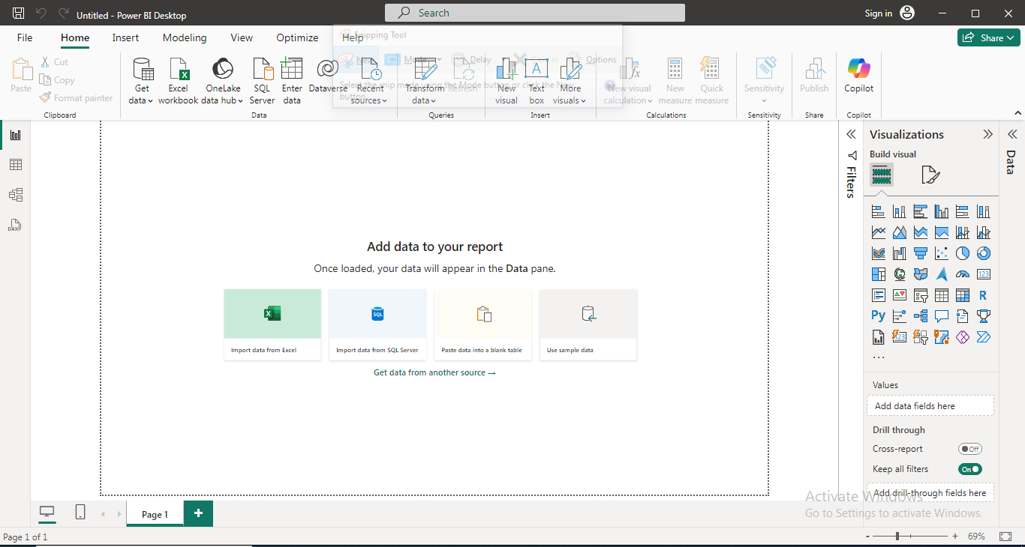

## 3: Uploading dataset

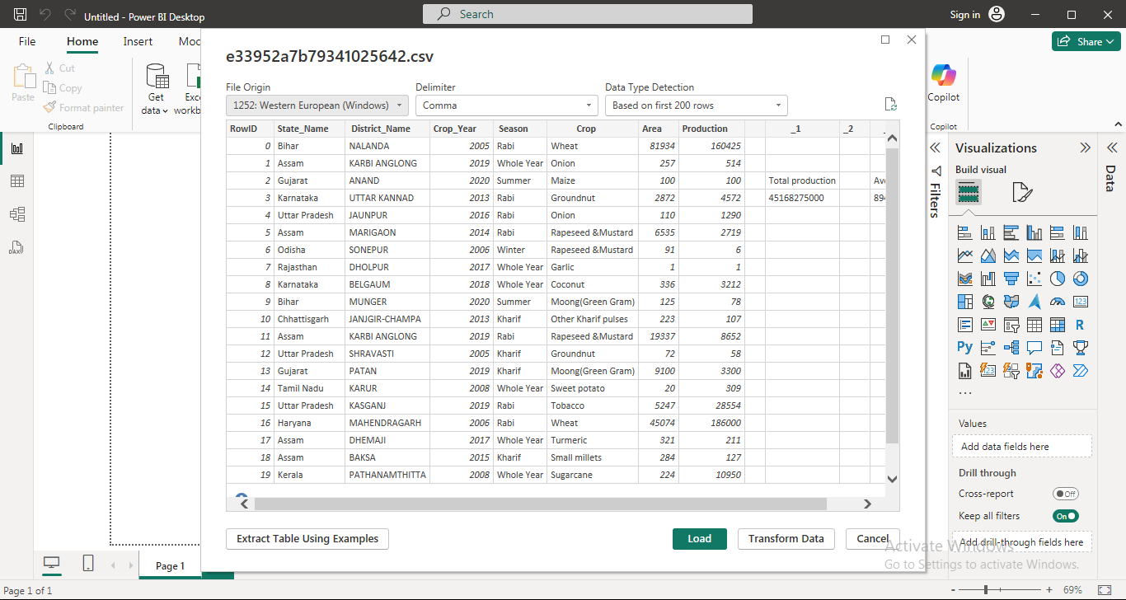

## 4: Dataset Uploaded

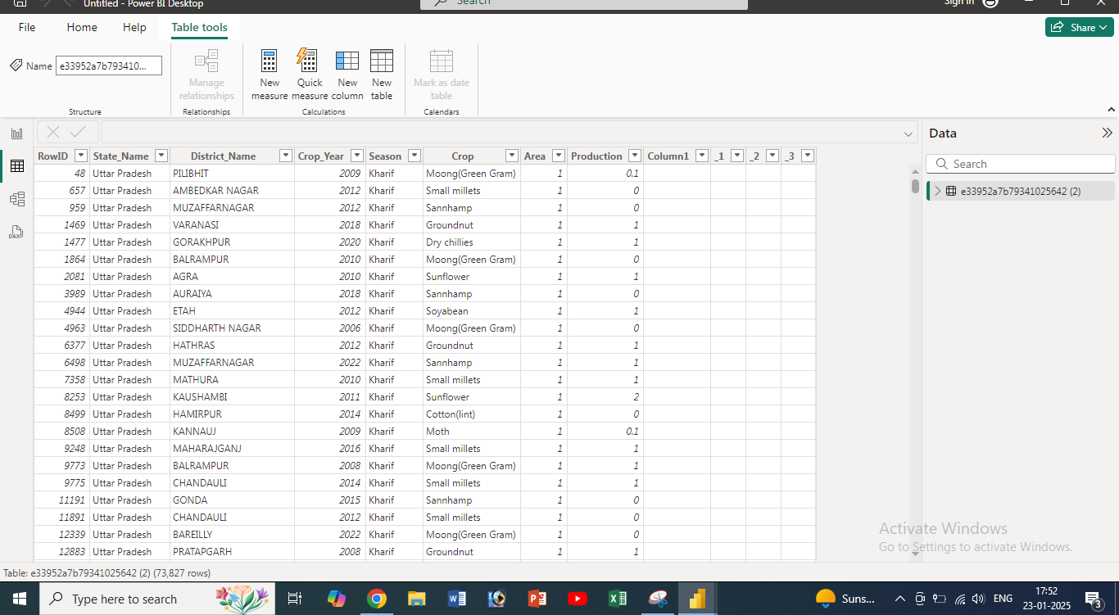

## 5: Transforming data using power query editor

## 6: Removing Useless (in our case row_id ) and blank columns

## 7: Useless (row_id) and Blank columns removed

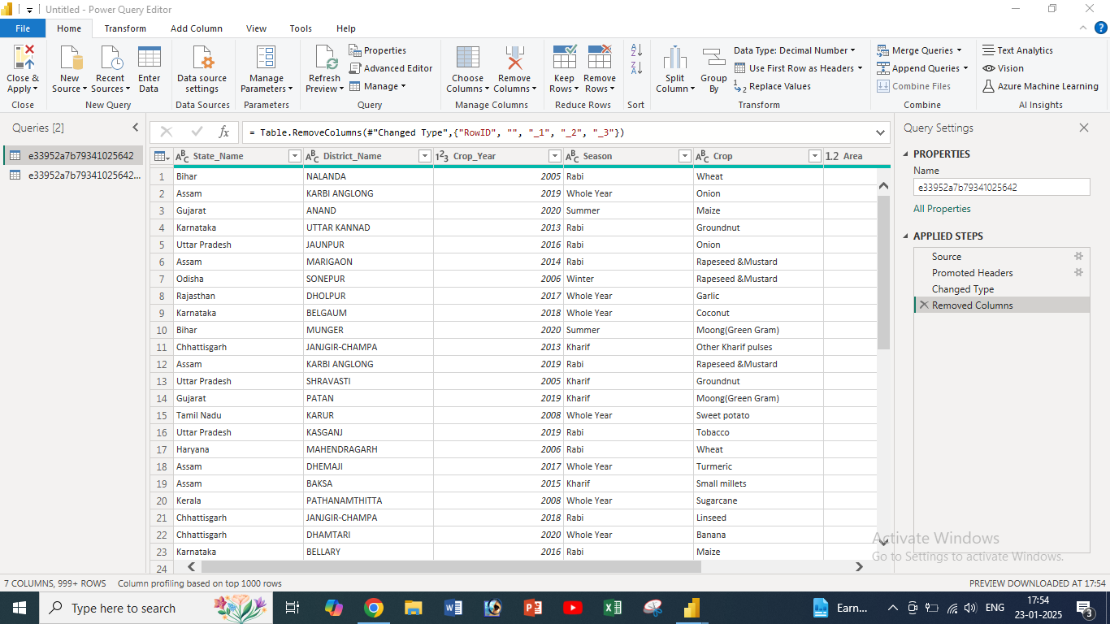

## 8: Saving file and completion of task

